

School of Digital Technologies

**PDE Systems Engineering for Robotics**

Final Report



**Recycling Robot**

**Name: Andrei Rutty**

**Submission: M00941399**

**Date of Submission: 14/04/24**

**Lab Tutor: Nivede Issur**

# Abstract

The vast majority of items being thrown away end up in landfills, where some might be recycled for repurposing . Consequently, there is a need for the development of an efficient recycling system which led to the advent of Sort X. Sort X is an eco-friendly autonomous recycling robot designed to autonomously classify items based on their material. Equipped with a real-time waste classification system and computer vision, it autonomously detects the material of the item and use a robotic arm to handle the item, all at a lower cost compared to other recycling robot.

To detect the presence of an item, Sort X utilizes an infrared and ultrasonic sensor to determine the presence of an item and distance from the sensors. Based on the sensor’s output, the pre-trained waste classification algorithm -built with Python and TensorFlow - will distinguish between the various types of items, reducing the chances of mixing different material types. Subsequently, the robotic arm will handle the item and drop it to its corresponding bin.

Future improvements to Sort X will involve enhancing the waste classification system by utilizing a larger dataset of items for material detection, with an emphasis on adapting to unconventional environment settings. Additionally, enhancing the robotic arm mechanism will improve the robot’s mobility and stability for handling items. Increasing the opening range of the grappler claws will enable handling of larger and wider items.

The main goal of this project was to offer a low-cost, eco-friendly, and autonomous recycling system that assist in the repurposing of items being discarded in households or a small business while being accessible to a wider audience.

Table of Contents

Abstract 0

Introduction 4

Aims and Objectives 5

Aims 5

Objectives 5

Literature review 6

Existing Similar System 6

Technologies Used 7

Sensors/Equipment Used 8

Design 11

Concept Behaviour 11

Design of functional component 12

Physical Design 14

Electrical Design 15

3D Sketch of Robotic System 16

16

Implementation 18

Physical Implementation 19

Code Snippets 22

Testing 31

Evaluation and Conclusion 34

Reference List 35

Table of Figures

Figure 1 - RoCycle sorting objects (Conner-Simons, 2019) 6

Figure 2 - Arduino Mega 2560 REV3 8

Figure 3 - SG90 9G Micro Servo Motor 9

Figure 4 - Webcam 9

Figure 5 - HC-SR04 Ultrasonic sensor 9

Figure 6 - IR Obstacle Avoidance Sensor Module 10

Figure 7 - Circuit Configuration 15

Figure 8 - 3D Sketch of Robotic System 16

Figure 9 -3D Sketch Top View 17

Figure 10 - 3D Sketch Side View 17

Figure 11 - Robotic Arm Physical Implementation 19

Figure 12 - Object Detector Physical Implementation 19

Figure 13 - Object Detection System Physical Implementation 20

Figure 14 - Whole System Physical Implementation 20

Figure 15 - System Top View 21

Figure 16 - System Front View 21

Figure 17 - Serial Communication Code 22

Figure 18 - Serial Communication Established 23

Figure 19 - Object Detection Function Code 23

Figure 20 - Fetching Data from Arduino Code 24

Figure 21 - Waste Classifier Code 25

Figure 22 - Metal Detection 26

Figure 23 - Plastic Detection 26

Figure 24 - Paper Detection 27

Figure 25 - Arduino Object Detection Code 27

Figure 26 – Robotic Arm Mechanism Code 1 28

Figure 27 - Robotic Arm Mechanism Code 2 29

Figure 28 - Robot Activation Code 30

Table of Tables

Table 1 - Sensors/Equipment Table 10

Table 2 - Pinout Table 18

Table 3 - Component Testing Table 32

Table 4 - Functional Testing Table 33

Table 5 - System Testing Table 34

# 

# Introduction

Pollution is tarnishing our planet. The world is rapidly evolving, and the silent but dreadful threat caused by pollution is becoming more apparent. It is ruining our beautiful environment, worsening people’s health, and wiping out our biodiversity. In Europe, poor air quality is still a major health hazard, 10% of premature deaths are related to pollution and many citizens are struggling to cope with pollution-related illnesses such as respiratory and cardiovascular diseases ([www.eea.europa.eu](http://www.eea.europa.eu), 2023). Poor waste management causes not mere air pollution, but water and soil pollution. “Around the world, one million plastic drinking bottles are purchased every minute, while up to 500 trillion single-use plastic bags are used worldwide every year. In total, half of all plastic produced is designed to be used only once and then thrown away” (UNEP, 2018). Open and unsanitary landfills contribute towards the contamination of drinking water causing infections and transmit diseases. Debris scattering pollutes the ecosystems and dangerous substances from electronic wastes like mercury, cadmium and brominated flame retardants jeopardize the health of urban dwellers and the environment (UNEP, 2017). Furthermore, with environmental degradation, the delicate balance of the Earth’s ecosystems is being disrupted, leading to severe ecological consequences. Loss of biodiversity where countless species are brought to the brink of extinction, leading to a disruption in the food chain causing a cascading effect on other species dependant on them for food (FasterCapital, n.d.). In light of these alarming problems, urgent action needs to be untaken to combat the thread which pollution causes and safeguard the planet for future generations.

Recycling robots have emerged and are increasingly becoming an indispensable tool in the management and reduction of waste pollution. According to the Environmental Protection Agency (EPA), the national recycling rate in the US is only 27.6% (United States Environmental Protection Agency, 2022). By using recycling robots, we can significantly improve these numbers. According to a World Economic Forum, recycling robots can increase the recycling rate by up to 92%, significantly outperforming the traditional manually sorting methods. Recycling robots’ significance lies in their ability to sort through waste streams at much faster rates and with greater accuracy than humans, allowing the recovery of more recyclable materials and divert them from landfills (Axios, 2023). Additionally, studies have shown that they can achieve an hourly picking rate of 2000 to 4000 picks compared to the mere 200 of a typical human. The promise of robotics is to change the waste recycling current methodology by increasing the speed of sortation while reducing cost (HowToRobot, 2023).

Yet, the cost of these robots can cost anywhere up to $300,000 according to HowToRobot making it inaccessible and too expensive for household or small businesses (Axios, 2023).Addressing this challenge requires the necessity to develop a low-cost and autonomous recycling robot, ensuring equitable access to an efficient waste management system. By implementing this robot, we can address the issue of poor waste management and contribute towards a cleaner and healthier environment.

# Aims and Objectives

## Aims

* Build and deploy a fully autonomous recycling robot utilizing cutting-edge AI and Machine Learning algorithms for accurate waste classification with the integration of computer vision functionalities through a camera and a robotic arm for precise and efficient item manipulation without any human intervention.
* Make a positive impact on the environment by implementing a system that aims to make recycling easier and more efficient with the use of accurate waste sorting techniques and the reduction of wastes deposited in landfills. By conserving resources, the goal of this project is contributed towards keeping our planet cleaner and create a healthier environment for everyone.

## Objectives

1. Implement and train an accurate waste classification AI model using Python.

The waste classification AI model will serve as the brain of the system. The main responsibility of this model will be to distinguish between the various recycling materials (plastic, paper, and metal) and to also identify non-recyclable items which will fall under the categories organic for food-based waste and others if the item does not fit in any of the categories mentioned previously. To achieve this, the AI model will undergo vigorous training on a very large dataset consisting of images of recyclable and non-recyclable materials. The end goal is expecting a highly accuracy in classifying waste items into the different categories.

1. Design and build a robotic arm.

For handling a diverse set of items, a robotic arm with dexterity and ability to manipulate a variety of objects of varying shapes, size and weights will be a pivotal tool for an autonomous waste sorting system. The primary function of this robotic arm will be in fetching the object from the user and deposit the item in its corresponding bin. The robotic arm will be equipped with a gripper design to securely hold the object preventing object drops or any object damage. Combining dexterity and precision will improve the robotic arm’s reliable and effectiveness in handling the diverse set of items.

1. Build an object detection system.

The object detection system will be pivotal in confirming objects presence, ensuring the robotic arm is to operate only when necessary. To achieve this, sensors will be integrated and will work in tandem to detect the presence of any object and verify that its position is within the acceptable detection range. By implementing this technology, the system will be enhanced in a way that it will be saving energy , optimize resource utilization and reduce unnecessary robotic arm operation.

1. Integrate a computer vision system using a camera.

A high definition camera will be used to capture real-time footage of waste items when detected within the detection range. The visual data from the footage will be used as input for the AI model for analysis and classification of waste item. With advanced image processing algorithms, the AI model will quickly recognize and sort the recyclable or non-recyclable items.

# Literature review

## Existing Similar System

A team led by MIT’s Computer Science and Artificial Intelligence researchers has developed a robotic system capable of detecting if an object is either made of paper, metal, or plastic (Conner-Simons, 2019).

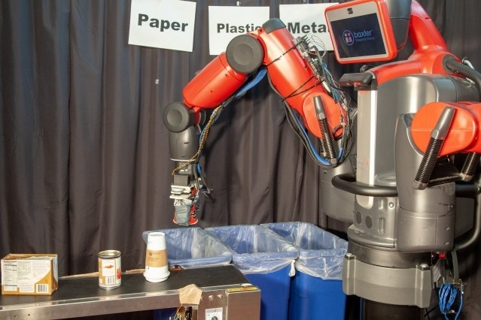

Figure 1 - RoCycle sorting objects (Conner-Simons, 2019)

The robotic system includes a soft Teflon hand that uses tactile sensors on its fingertips to detect an object’s size and stiffness. A special material called “auxetics” – a material with negative Poisson’s ration – was used by the scientists for this robot. The robot is able to differentiate between a vast array of objects with the haptic feedback provided by the robot’s sensorised skin(Despatch, 2019). RoCycle was found to have an 85% accuracy in material detection when the items where stationary and 63% accuracy when objects were placed on conveyer belt (Conner-Simons, 2019).

The MIT team used a motorised hand made of auxetics because of its ability to become wider when stretched compared to most material which exhibit rubber-like behaviour. As a result, they were able to obtain a more dynamic arm movement by implementing auxetic on each of the robots hand making them interlock and oppose each other’s rotation. To estimate the size of an object, the gripper uses a “strain” sensor and then uses 2 pressure sensors to estimate the required force to hold the object. The gripper then determines the material of the object using the measurements and data from the sensor which tells about the size and stiffness of the object. Because the tactile sensors are conductive, metal can be detected by measuring the change in electrical signal( MIT News | Massachusetts Institute of Technology, n.d.).

RoCycle incorporates a sensor system that can differentiate between soft and hard objects with an accuracy of 78 percent and can measures the object radius to within 30 percent precision. The robotic hand is also nearly immune to punctures remaining mostly intact after being pierced more than 20 times by a needle and scraped by a sharp lid(Conner-Simons, 2019).

However, the main drawback about RoCycle is the speed factor. It takes time to pick each individual item. In an industrial recycling facility, RoCycle might be excessively slow in this regard because it is very costly to operate, and they must process garbage fast. For example, robots with the likes of the ZenRobotics are able to sort 4000 things hourly. According to Holopainen, RoCycle would have to work about 10 times faster to compete with them. To alleviate this issue, the team is aiming to integrate its touch-based robot with a visual system which will pick up just those objects it wasn’t sure about after scanning it (MIT Technology Review, n.d.).

By including additional sensors and enhancing the system’s sorting algorithms, the team is now working to further develop the system. “The researchers hope that such a soft robotic feature can be implemented into an optical sorting system that are already being used, thus enhancing recycling efficiency and facilitating more sustainable waste-handling practices – something that’s urgently needed around the world” (Mok, 2019).

## Technologies Used

Recycling robots are technological wonders that perform the duty of waste management with high accuracy and efficiency. These devices are powered by a powerful combination of computer vision and Artificial intelligence (Fahrion, 2024).

Robots using artificial intelligence transforms how robots interact with their surroundings by giving them the capacity for autonomous perception, learning and decision-making through the use of state-of-the-art algorithms and techniques (luciaclemares, 2023). Training an AI model on platforms like Teachable Machine – a web-based tool that makes creating a machine learning models fast, easy, and accessible to everyone - empowers you to create a unique AI system tailored to a user’s specific needs, in this case an AI system to sort object based on their material type. This results in a major benefit for the recycling robot as Teachable Machine interface allows for easy customization of the AI model and the robot’s capabilities in sorting waste by training the model on frequently encountered waste items. Teachable Machine serves as a pivotal tool for creating an intelligent and versatile recycling robot because of its accessibility and ease of customization (Google, n.d.).

Computer vision – a branch of artificial intelligence – gives a machine the capacity to see and understand their surroundings. It includes extracting meaningful information from digital photos, videos and other visual inputs in a similar way humans use their eye and minds. Computer vision applications includes image classification where it can predict that a given image belongs to a certain class, object detection and tracking to identify a certain class of image and to follow the tracks of an object once detected and it can retrieve content from large datasets and annotate them (IBM, 2019). Python provides the world’s biggest computer vision library which is OpenCV. Open Source Computer Vision is ,simply put, a library used for completing tasks that requires image processing and computer vision applications in areas powered by artificial intelligence and machine learning algorithms. It enables anyone to process images and videos to identify objects, faces, or even human’s handwriting. There are lots of application which make use of OpenCV including in robotics with object detection where it focuses on identifying instances of semantic objects of a certain class in digital images and videos (YoungWonks, n.d.). OpenCV is known for its ease of use because it can be implemented using the widely used Python programming language making its syntax clean and understandable. It’s wide range of image processing functionality can OpenCV very versatile and suitable for a wide range of application. With an extensive and comprehensive documentation, developers can easily understand and use the library effectively ([www.linkedin.com](http://www.linkedin.com), n.d.).

## Sensors/Equipment Used

|  |  |  |  |
| --- | --- | --- | --- |
| **Component**  **Image** | **Component Name / Model** | **Quantity** | **Purpose/Description** |
| Figure 2 - Arduino Mega 2560 REV3 | Arduino Mega -  2560 REV3  [A000067] | 1 | The Arduino mega will serve as the brain of the robotic arm, receiving and processing input data from a python program to control the movement of the servo motors. It will manage the entire processing of the robotic arm during item manipulation. It will send data read from sensor to the python program via serial communicartion.  The extra I/O pins, and serial ports provide room for multiple servo motors for the robotic arm and potentially additional sensors for gameplay, and it can easily be expanded with added features and functionalities.  **(www.javatpoint.com, n.d.)**  With its 8Kb SRAM, it has more space to manipulate large amount of data and complex algorithms for chess strategies. More variables can be created when it runs.  **(www.javatpoint.com, n.d.)** |
| Figure 3 - SG90 9G Micro Servo Motor | Servo motor – SG90 9G Micro Servo | 4 | Responsible to rotate at a specific angle to precisely control the robotic arm movements for item manipulation. Each servomotor corresponds to a part of the joint, arm and base, allowing it to mimic a human’s arm movement.  Robotic arms that use servo motors usually have about 6 degrees of freedom, which is almost as many as those found in a human arm.  **(evs, 2023)**  The arm will be able to move a whole 360 degrees in either direction with high level of accuracy. The inbuilt actuators rely on feedback from encoders, and they are always on the lookout for the slightest changes in positions so they could readjust in split seconds.  **(evs, 2023)** |
| Figure 4 - Webcam | Webcam | 1 | The webcam will be used to capture live video footage of the recyclable item during object classification.  The OpenCV image processing library will be used with an AI model to classify each item presented according to its category. With image processing algorithm provided by OpenCV, the webcam will be able to differentiate between the different items category irrespective of their shapes, colour or unique characteristics. This will help the robotic arm to accurately pick up and deposit the item in its corresponding bin. |
| Figure 5 - HC-SR04 Ultrasonic sensor | Ultrasonic Sensor – HC – SR04 | 1 | An inexpensive and low power devices capable of reporting and measuring the distance from an object to the device with a range of 13 feet.  The ultrasonic sensor will ensure that the object is placed within an acceptable range for the robotic arm to fetch the object. By placing the sensor in calculated locations, while facing the upward direction, it will emit and receive ultrasonic waves to measure the distances of the object from the location of the sensor. Upon detecting an object’s ultrasonic waves, the Arduino will take the data from the sensor and transmit it to the python program which will proceed the data.  If the object is placed too far away, a voice alert message will be triggered by the program to ask the user to bring the object closer to the sensor.  On the other side, if the object is placed within acceptable range, a voice message will be triggered by the program informing the user that the object has been detected, followed by the activation of the robotic arm processing. |
| Figure 6 - IR Obstacle Avoidance Sensor Module | Infra-red sensors –  10pcs IR Obstacle Avoidance Sensor Module | 1 | An electronic device that detects infrared waves within its surrounding.  When the sensor detects infrared emission that is an object has been detected in front of the signal, the led indicator on the board will light up.  The IR sensor will servo a similar purpose with the ultrasonic sensor as they work together for the object detection system. It ensures the object is placed within acceptable range of the object detector device. The sensor will detect infrared sensor between a distance of 2 to 30 cm and upon detecting infrared waves, the Arduino will take the data from the sensor and transmit it to the python program which will proceed the data.  If the object is placed too far away, a voice alert message will be triggered by the program to ask the user to bring the object closer to the sensor.  On the other side, if the object is placed within acceptable range, a voice message will be triggered by the program informing the user that the object has been detected, followed by the activation of the robotic arm processing. |

Table 1 - Sensors/Equipment Table

# Design

## Concept Behaviour

**How the system works as a whole**

1. When a user puts an item on the objct detector, the IR module sensor will detect and confirm the presence of an object and the HR-SR04 ultrasonic sensor will verify if the user has positioned the item in the acceptable range.
2. If the object is not within the range, a voice message will be played asking the user to bring the object closer to the detector.
3. The camera captures the real-time footage of the item placed before it. The footage is sent to OpenCV for image processing.
4. The footage received by OpenCV will be then analysed using OpenCV’s algorithms.
5. OpenCV will send data to the AI model which will use in classifying and sorting the items into the different recyclable or non-recyclable item categories.
6. When the items category has been found, the AI will send the category to the Arduino board via serial port transmission.
7. Upon receipt of the category, the Arduino will rotate the arms’ servo motors 30 degrees forward. This will move the arms claws forward towards the object.
8. Then the Arduino will rotate the claws servo through 35 degrees opening the claws waiting for the user to insert the item between them. The period during which the claws are open is approximately 3 seconds..
9. Then the Arduino will rotate the claws servo back to its original position and rotate the arm’s base servo motor towards the corresponding bin. The degree to which it should rotate is already predefine for each category.
10. When it reaches the bin, the claws will open and close, depositing the item.
11. Finally, the robotic arm returns to its initial position.
12. The steps 3 to 11 are repeated when another object is found.

**Social Interaction**

*Human to Robot*

When a user approaches the object detector with a recyclable item and puts it over the detector, the recycling robot quickly activates itself and start the recycling process. When the claws are opening, the user can put the item between the claws and then they can close. This will allow the user to feel a seamless blend of human action and technical efficiency throughout this user-friendly process, which encourages engagement and empowerment in sustainable behaviour.

*Robot to Human*

Upon placing the item too far from the object detector, the system will trigger a voice feedback message alerting the user that the object is too far and should be placed much closer. This notification will ensure the seamless error-free operation of the robot. Similarly, upon successful item placement over the detector, the system will trigger a voice feedback message alerting the user that their item was detected and the recycling process can start.

## Design of functional component

This section will illustrate the design and implementation process of the various function that were used in building this project.

**Waste Classifier AI algorithm.**

The first step in designing an AI waste classifier is gathering a large dataset of images of various frequently encountered waste products of varying shapes and size. For this model, a dataset of approximately 6000 images were gathered. Next the dataset is split up according to the different categories for training, testing and validation. The website teachablemachine.withgoogle.com was used for training the AI model as the website provides quick and easy steps to train an AI by simply providing example images and dragging and dropping files into different categories which are called classes. To improve the AI’s accuracy, it allows insertion of new sets of images to already trained models (Google, n.d.).

Once the AI has undergone the training process, the waste classifier is integrated into the recycling robot’s software system. In order to predict the waste’s category, the AI model takes real-time footage from the camera and runs them through the trained model. Ensuring smooth communication between the classifier and the Arduino with its actuators is also part of the integration. To maximize the classifier’s accuracy and performance in real-world scenarios, different lighting environment, object orientation and background objects were considered. With continuous fine-tuning of the model, the recycling robot can easily classifier different waste presented to it, hence promoting effective recycling process.

**Computer Vision using opencv.**

The design and implementation of a computer vision system will involve numerous crucial steps. The AI waste classifier model must have already been fully trained, and the level of accuracy needed for high sorting rate is a necessity. Python with opencv and other associated libraries are used for the image processing application due to its vast array of cutting-edge functions suitable for computer vision related tasks. And with the help of associated libraries like cvzone, which integrates a classifier module, the AI waste classifier will be easily integrated into the computer vision system. For live visual data input, the camera will be set up, with correct calibration and orientation to guarantee net image quality, contributing towards a high level of accuracy in the AI algorithm.

Next, OpenCV and associated libraries will be used to develop the fundamental computer vision algorithms that integrates the use of the live camera footage and the AI waste classifier model. The actions performed by the robotic arm are synchronized with the recognized trash items. The communication between the camera, opencv and the Arduino board controlling the robotic arm servos is initiated and coordinated by the python scripts, which guarantee a smooth and effective operation of the sorting system(Greater details will be provided below).

**Object Detection System.**

In order to precisely detect and quantify the distance from the items to the detector device, an IR and ultrasonic sensors must be integrated into the design of this object detector system that will be the trigger for the activation of the robotic arm process. The two sensors will work in tandem. The HC-SR04 ultrasonic sensor will be used to measure the distance from the detector to the item ensuring the item is within the acceptable range and the IR module sensor for detecting the presence of object within the field of the detector. Arduino C++ code is used for programming the detection system and retrieve data from sensors and send them to the python script via serial port.

The IR sensor detects an object, and the ultrasonic sensor calculates the object’s distance from the sensor. The data is sent to the python code for analysis and checking their validity. A voice feedback message will be triggered to alert the user that the object was successfully detected, and the classification process can begin. Furthermore, another voice message will be triggered upon invalid data indicating that the sensor found the object to be too high or beyond the acceptable distance range. The the voice feedback message is implemented using the pyttsx3 module which is a text-to-speech python library.

**Communication between Arduino and AI Python Script**

The process of building an Arduino to Python communication system includes creating a smooth communication port for the Arduino board to control servo motors rotation based on python classification functions results and for the Arduino board to transfer sensor’s data to the python code for object detection and voice feedback message trigger. Initially, serial communication protocols are configured on the Python script and Arduino’s ends to allow for smooth full-duplex data transmission via USB connection. The PySerial package for python makes communication easier by enabling commands to be sent to and data to be received from the Arduino board within the Python program. The Arduino code runs concurrently, send data from the respective sensors, and listen for commands from the python script, and respond accordingly by actioning the robotic arm’s servo motors rotation.

Threading was employed in the python code to improve the speed and efficiency of the program by allowing for simultaneous execution of tasks. To be more precise, a thread was used specifically to receive data from the Arduino board, which allows the program to check the validity of the data received for the object detection system and this will allow the voice feedback and waste classifier to operate independently without waiting for commands from the Arduino board. By using multithreading, resource usage and responsiveness are optimized, enabling the recycling robot to simultaneously sort and detect objects in real-time and communicate with the Arduino board.

**Robot Mechanism**

The recycling robot’s arm mechanism must be designed with a number of important factors in mind, ensuring smooth and frictionless operation and item manipulation. Firstly, the arm’s mechanical construction allows for the 3-dimensional range of motion needed to grip and sort various waste items. To guarantee accurate and dependable movement, this involves the proper choice and positioning of the servo motors. Furthermore, the arm’s end effector, usually a pair of claws, is made to hold waste materials as effectively as possible with items fall or damage.

The robotic arm begins to move when the Arduino board receives the waste material class ID from the Python program. This entails rotating the arm’s servo motors to rotate through 30 degrees anticlockwise to move the claws towards the object, then actioning the claw’s servo motor to rotate through 35 degrees anticlockwise to open or 35 degrees clockwise to close the claws so that the waste item can be grasp and deposit in the correct bin. The arm’s base servo motor is then made to rotate towards in the direction of the pre-defined bin location that corresponds to the waste material class that was detected. This predetermined rotation guarantees effective sorting without requiring real-time computation, simplifying the robotic arm’s operation, and improving the recycling process’ overall speed and precision.

## Physical Design

The Arduino Mega 2560 Rev3 is the best option for this AI-powered recycling robot project because of its many features that are specifically designed to meet the full requirements of the project. The Arduino Mega has an astonishing 256KB of flash memory, which is more than enough to hold the algorithms and data needed for applications like computer vision and robotic arm control. Moreover, its large 54 digital I/O pins provide smooth interface to a variety of sensors, such as the IR module sensor and HC-SR04 ultrasonic sensor, enabling accurate object detection (Arduino Official Store, n.d.). Although a Raspberry Pi might have more computing power, it is not considered necessary to include one in this project. The camera does all the image processing, greatly reducing the amount of computing process on the Arduino Mega, which can instead focus on effectively handles the complex control logic. The project doesn’t demand much power consumption, networking capabilities and advanced AI or image processing capabilities, so the Arduino remains the ideal choice. Furthermore, the complexity of the Linux-based environment of the Raspberry Pi might presents a steeper learning curve, delaying the delivery of this project ([www.linkedin.com](http://www.linkedin.com), n.d.).

### Electrical Design

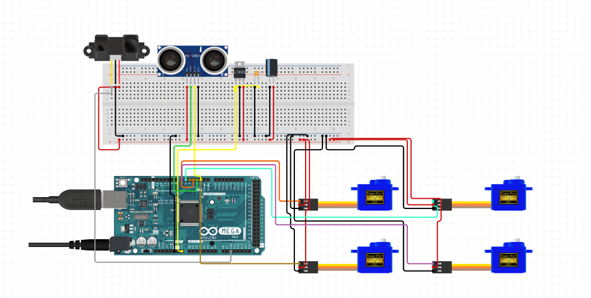

B

C

A

D

Figure 7 - Circuit Configuration

Index:

1. Arduino Mega 2560 Rev3
2. SG 90 Micro Servos
3. HR-SR04 Ultrasonic Sensor
4. IR Sensor Module

### 3D Sketch of Robotic System

## 

G

E

D

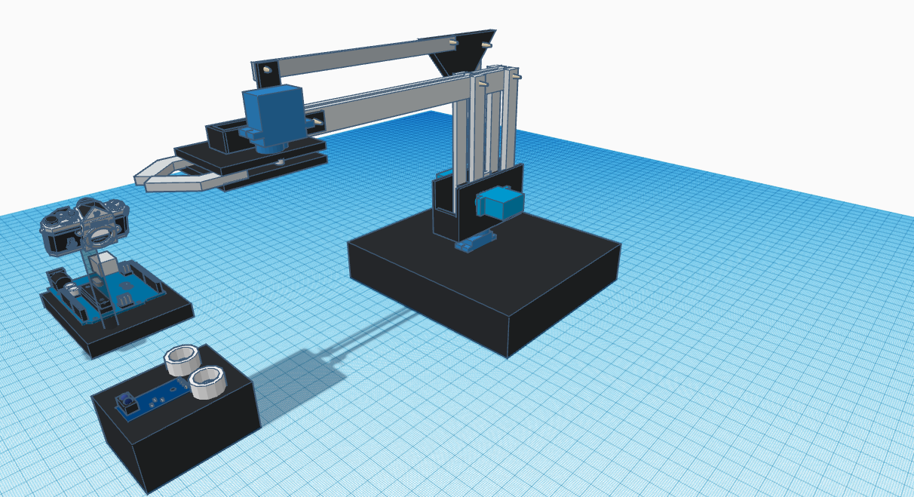

H

F

A

B

C

Figure 8 - 3D Sketch of Robotic System

Index:

1. Arduino Mega 2560 Rev3
2. IR Sensor Module
3. HC-SR04 ultrasonic sensor
4. Servo 1: Claws
5. Servo 2: Left arm
6. Servo 3: Right arm
7. Servo 4: Base
8. Camera

Top View

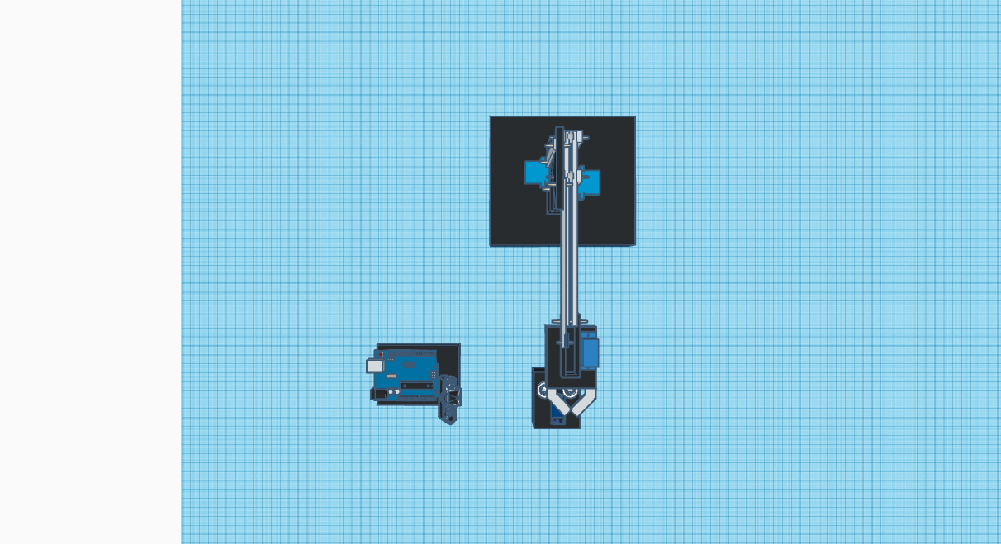

Claws

Base

Object Detector

Figure 9 -3D Sketch Top View

Side View

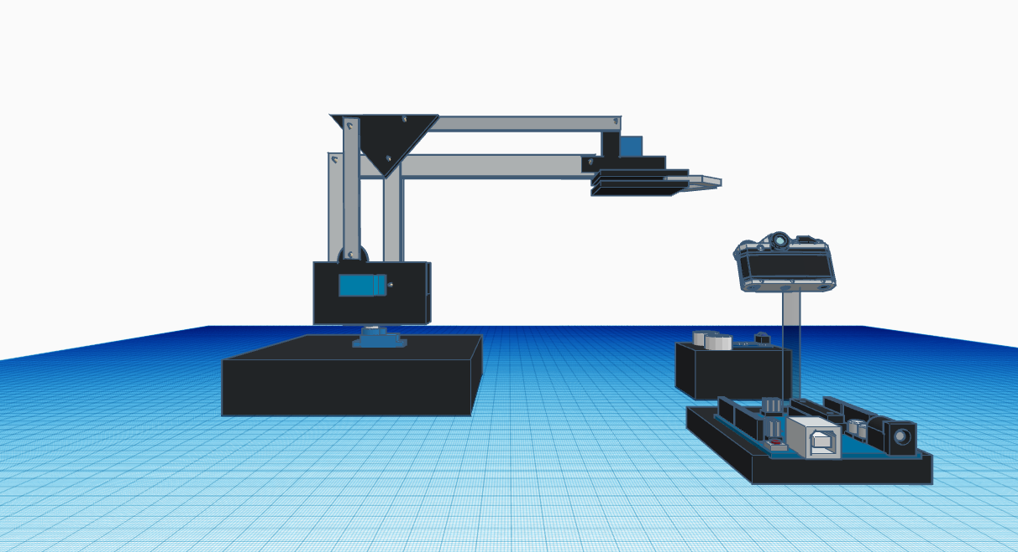

Figure 10 - 3D Sketch Side View

Sort X serves as an efficient waste management tool. It utilizes an AI waste classifier model to correctly sort the different waste types with the aid of the camera and opencv computer vision algorithms which examines the visual data from the camera and object detector. The camera sends the visual information to opencv after the object detector has detect and confirmed the presence of an object. Then the AI model there proceed in identifying the object material category based on the dataset with which it was trained. Upon detecting the object category, the robotic arm will be activated to handle the item with precise movements capable of carrying out physical tasks like transporting the item from the user’s hand to its designated bin.

The robot operates according to defined processes designed to handle and classify waste effectively. The operation is initiated by the user placing an item on the object detector which will confirm the presence of an object. Upon detecting an item, the camera will transfer the visual data to opencv which will use the AI waste classifier to identify the item’s material category and will send the result to the Arduino board to rotate the servo motors. The robotic arm will take the item and deposit in its corresponding bin, hence completing the process.

# Implementation

This section demonstrates the final version and actual implementation of the recycling robot, Sort X. Furthermore, code snippets of the robot’s functionality will be demonstrated and explained in detail.

Pinout Table for Arduino Mega 2560 Rev3

|  |  |
| --- | --- |
| **Component** | **Pin Number** |
| IR Sensor Module | 5 (Digital Pin) |
| HR-SR04 Echo | 6 (Digital Pin) |
| HR-SR04 Trigger | 7 (Digital Pin) |
| Servo 1 | 8 (Digital Pin) |
| Servo 2 | 9 (Digital Pin) |
| Servo 3 | 10 (Digital Pin) |
| Servo 4 | 11 (Digital Pin) |

Table 2 - Pinout Table

### Physical Implementation

Robotic Arm

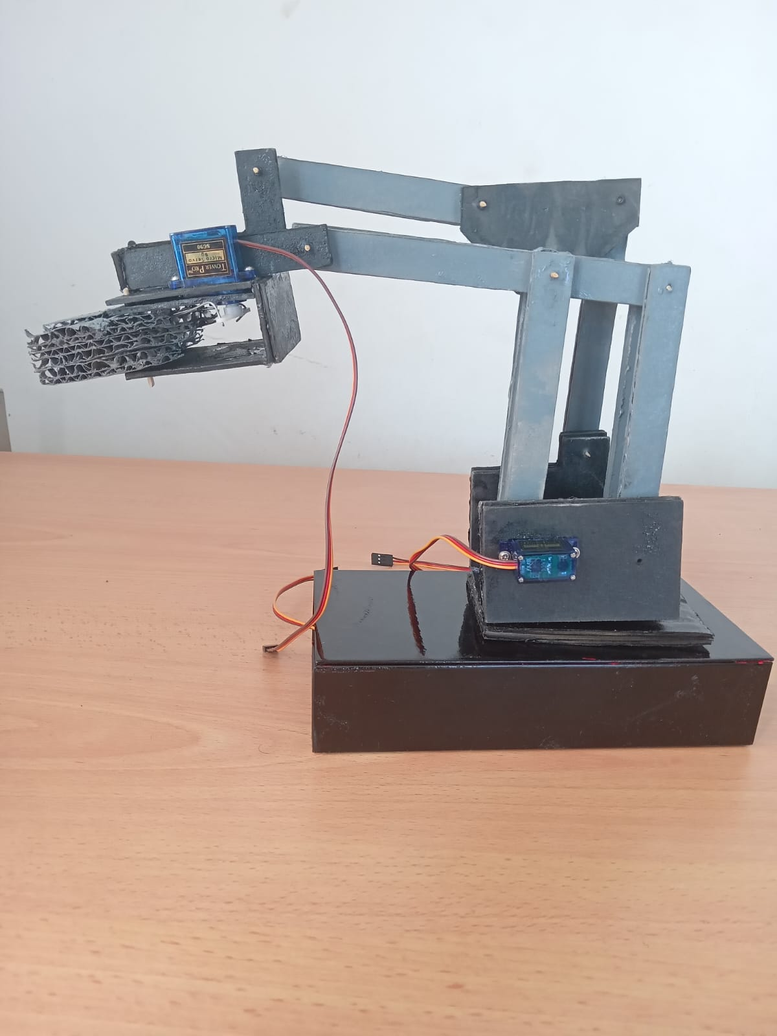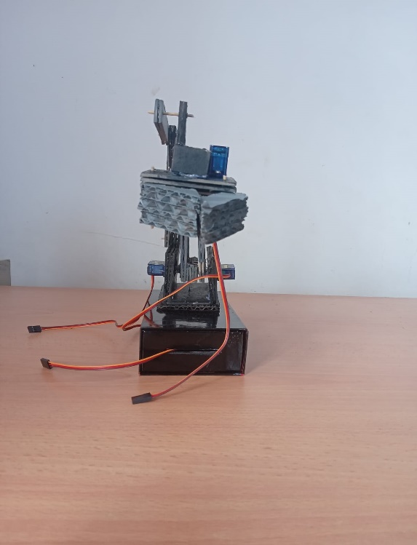

Figure 11 - Robotic Arm Physical Implementation

Object Detector

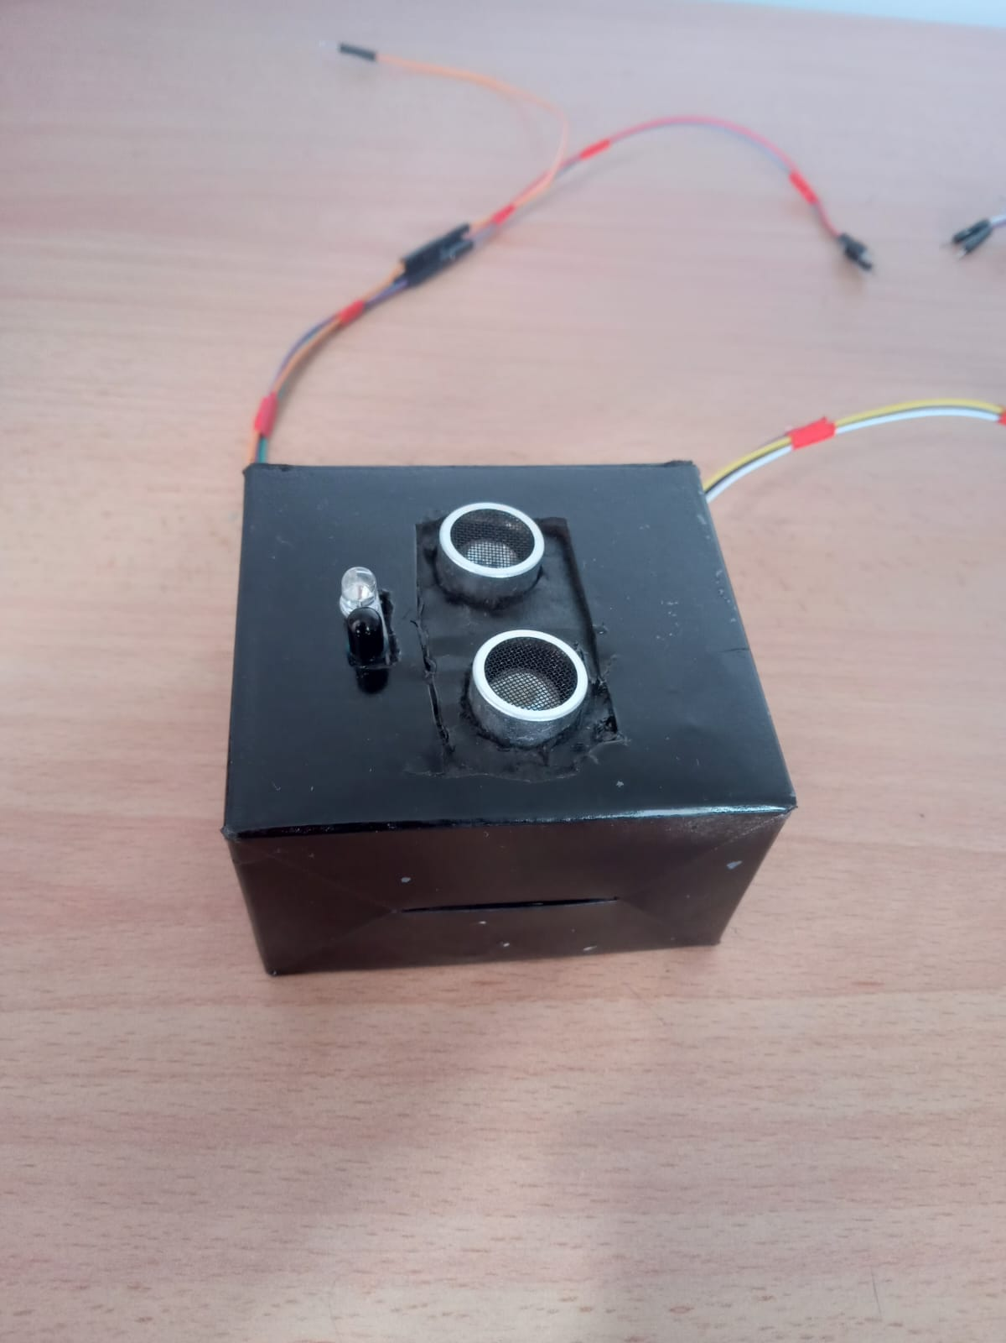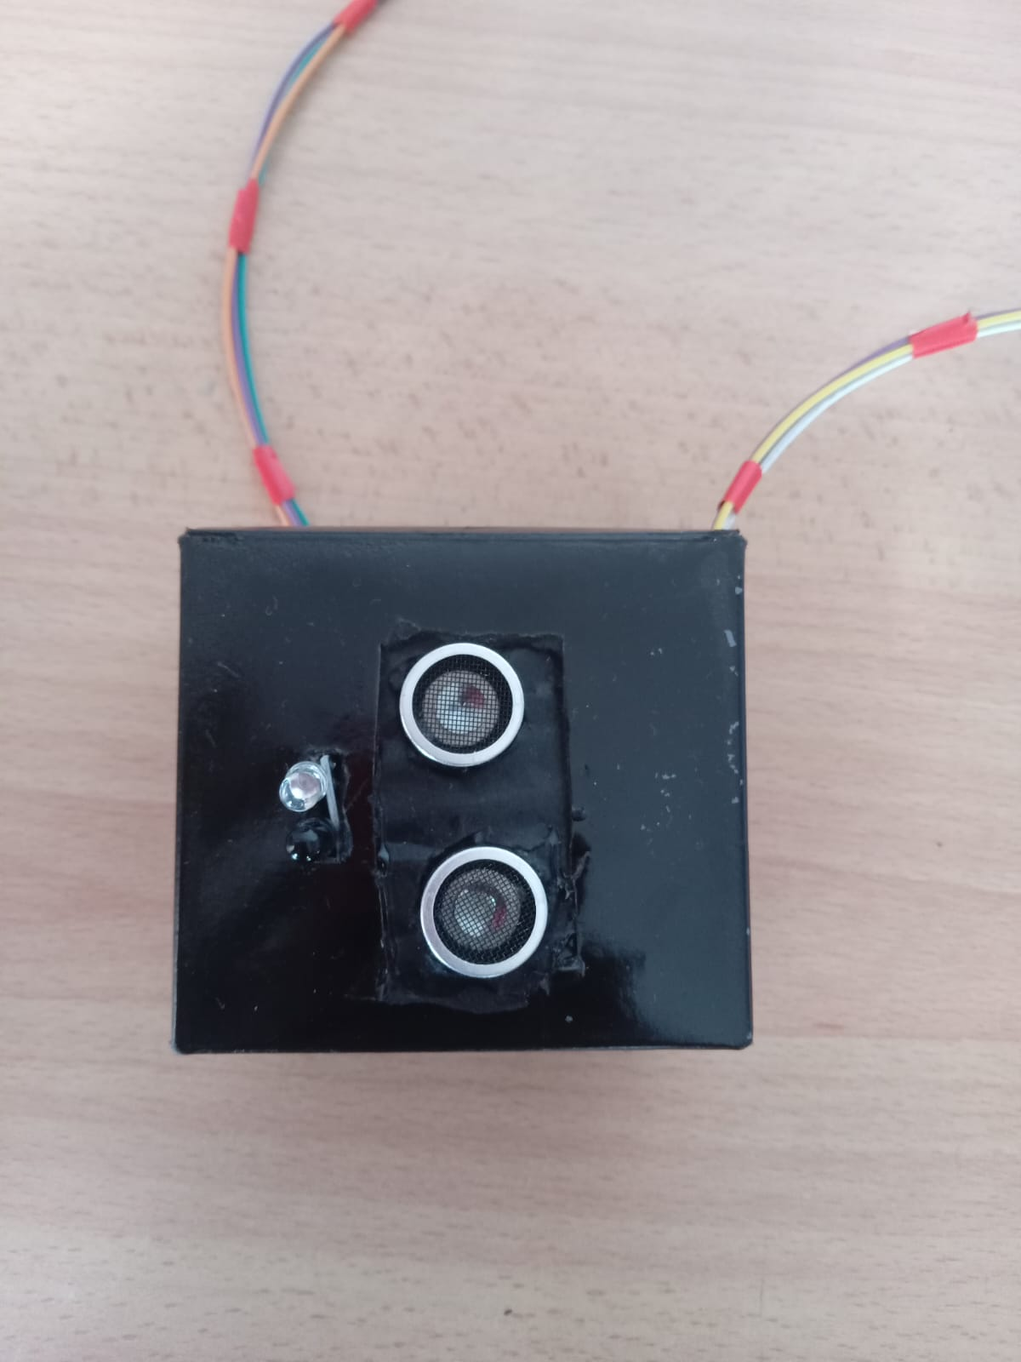

Figure 12 - Object Detector Physical Implementation

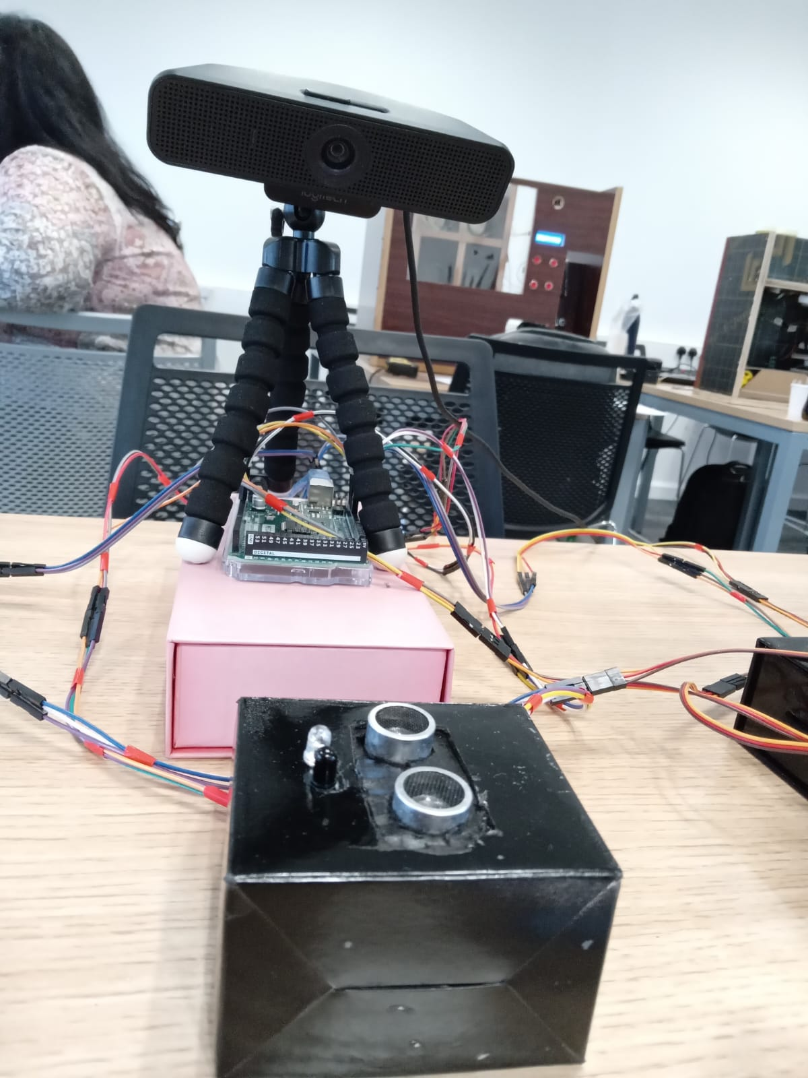

Figure 13 - Object Detection System Physical Implementation

Whole System

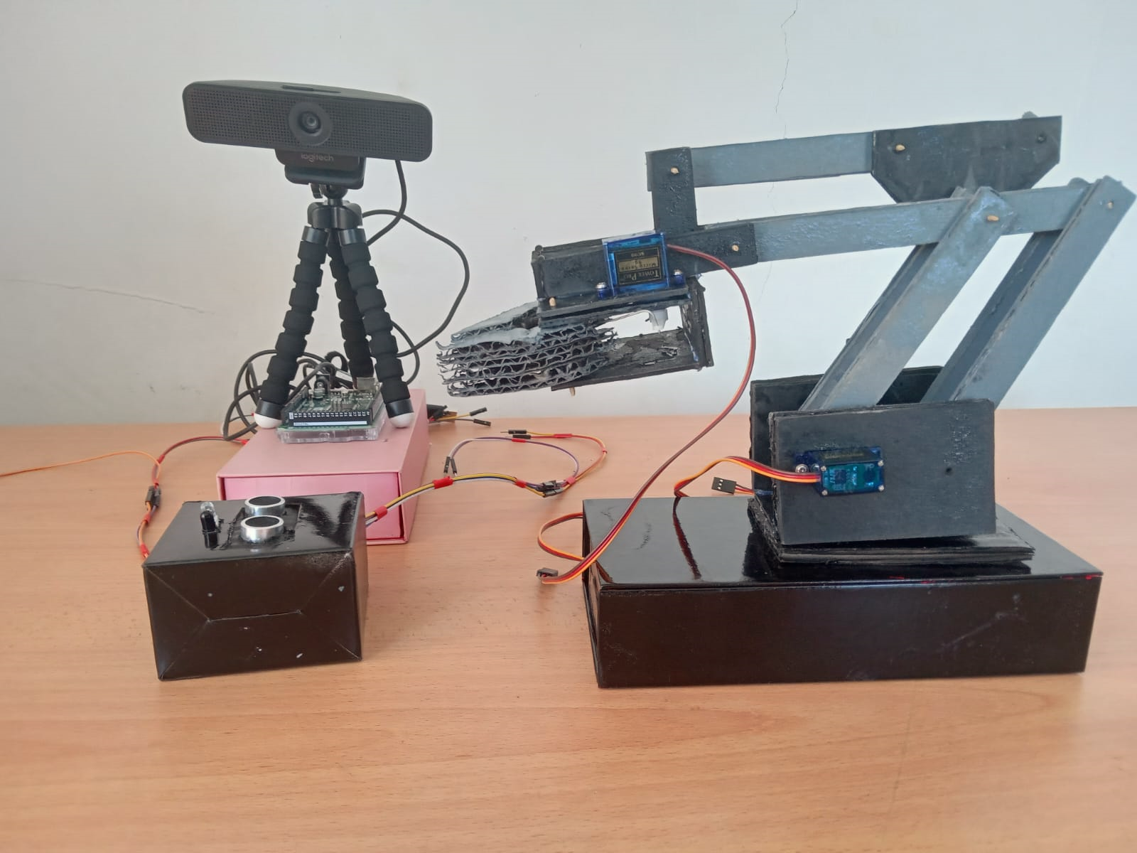

Figure 14 - Whole System Physical Implementation

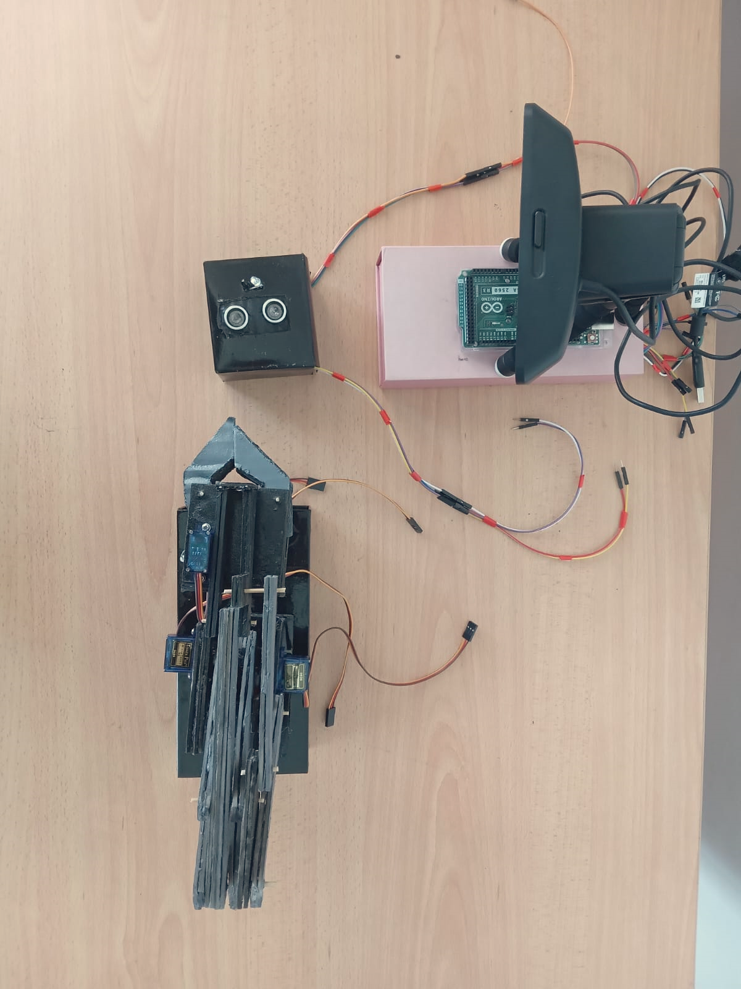

Figure 15 - System Top View

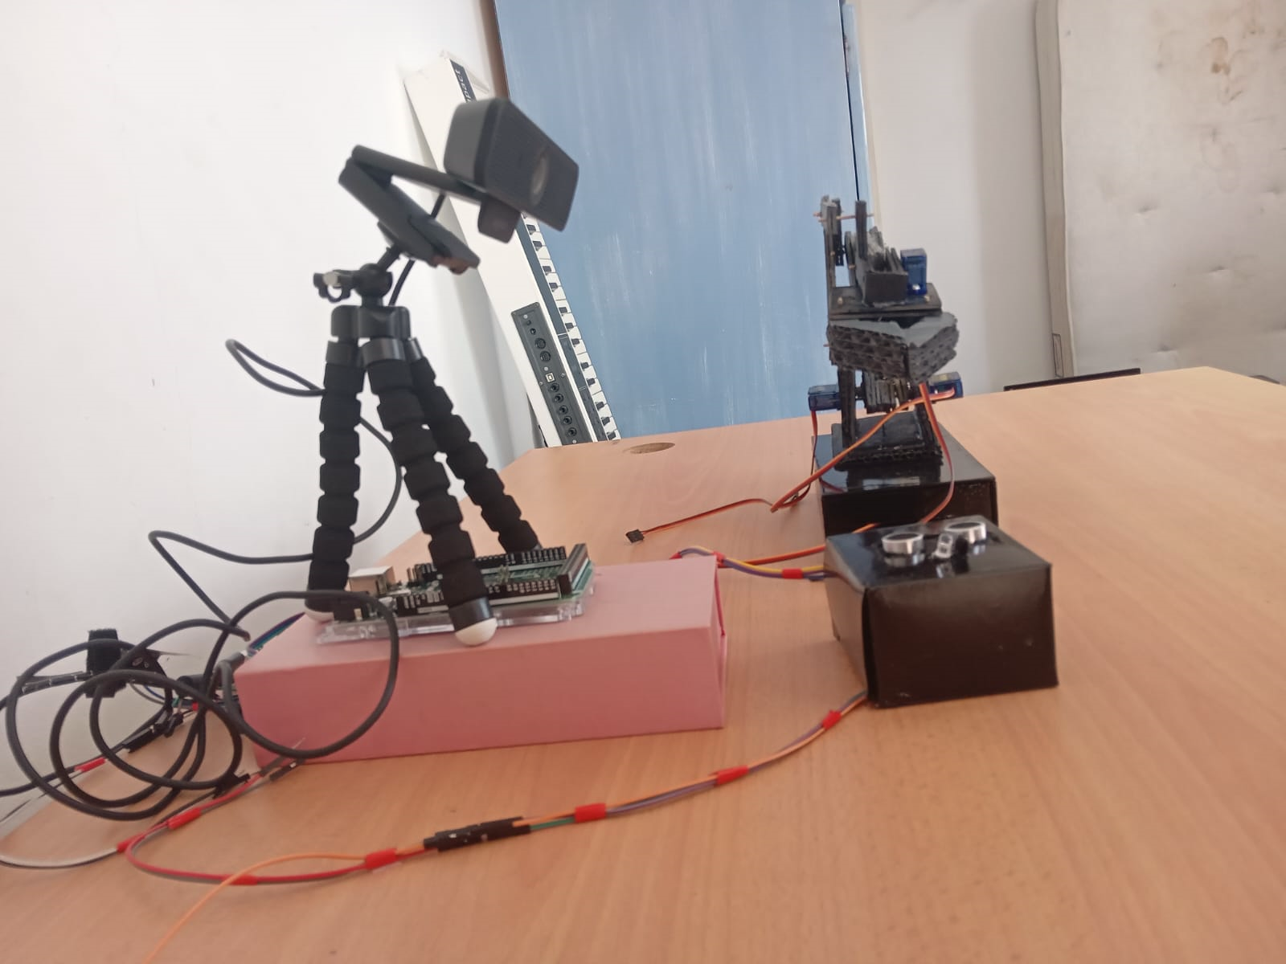

Figure 16 - System Front View

### Code Snippets

**Main.py**

To start the robotic system, the user shall execute the main.py file from their computing device. Before running the file, the Arduino Mega , with the appropriate code uploaded, should be connected to the user’s device via USB.

Serial Connection between Arduino Mega and Main.py

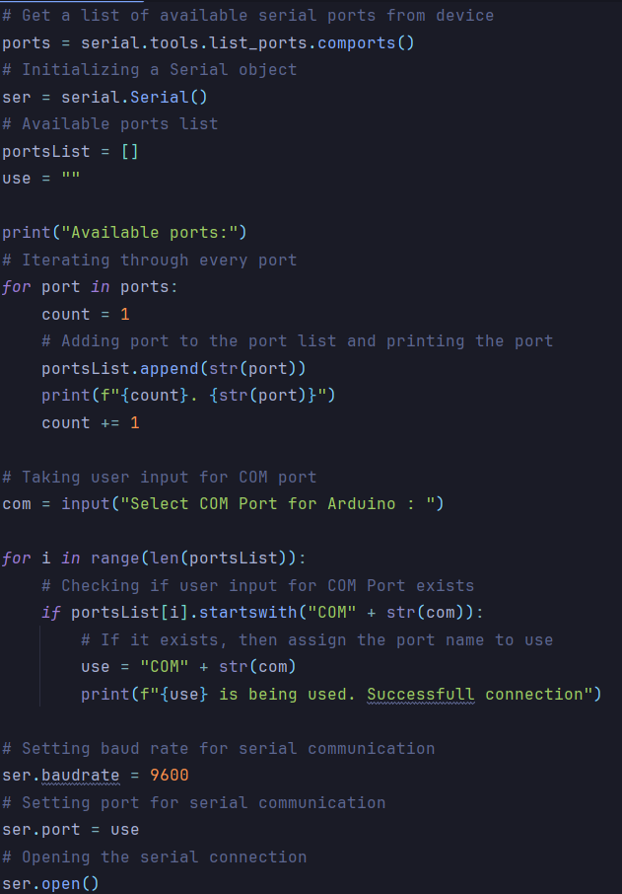

Figure 17 - Serial Communication Code

When the user executes main.py, the user will be asked to choose the port for communicating with the Arduino board. The user will be prompted with a list of available port from the device and will have to choose the appropriate one to establish the connection. Upon choosing the correct port, the serial connection will be opened within that port number.

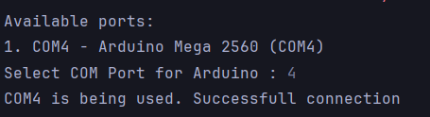

Figure 18 - Serial Communication Established

Object Distance Verification

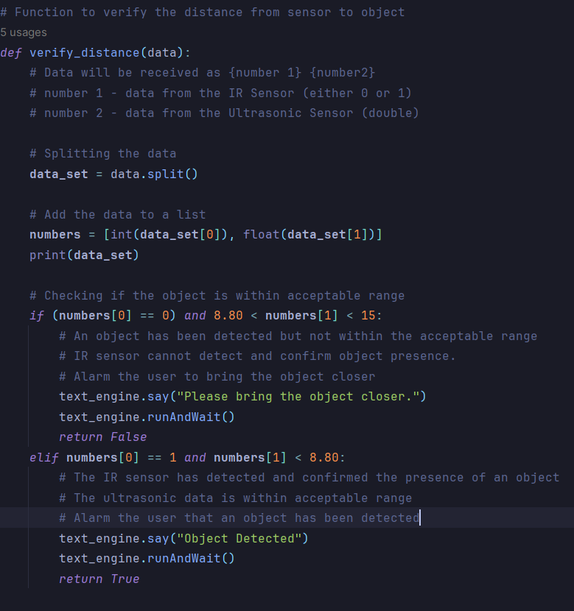

Figure 19 - Object Detection Function Code

The distance verification function takes a string as parameter which contains the values from the respective sensors. The string is split up and the 2 numbers retrieved will be compared respectively against acceptable data. The first check will involve checking if there is an object outside the range (distance between 8.80 and 15 cm) as the IR sensor returns 0 indicating it didn’t detect any object. If this is the case, the program will trigger the warning message asking the user to bring the object closer and the program will redo the distance verification. If for instance the IR sensor returns 0 and the ultrasonic sensor returns a value less than 8.80 cm, then the robot can be activated.

Data Fetching and System Activation

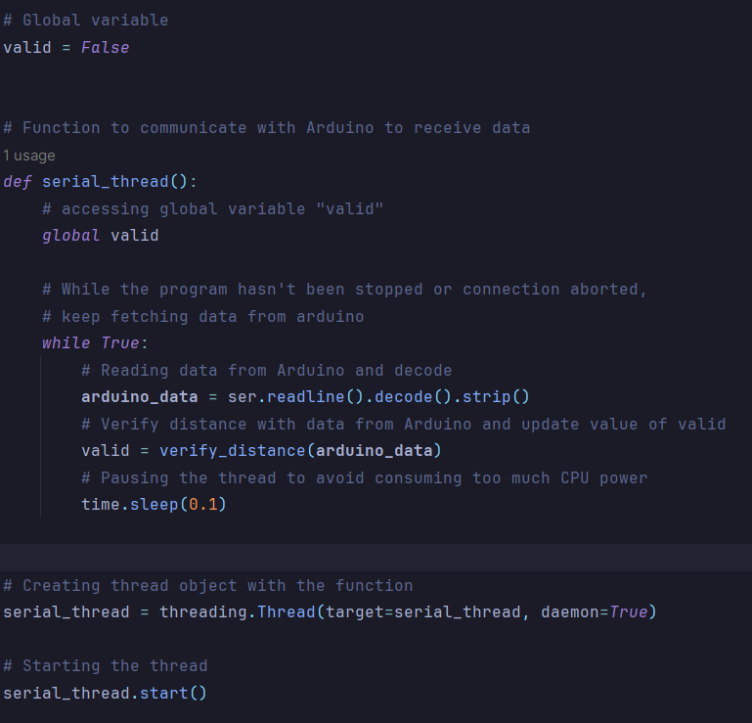

Figure 20 - Fetching Data from Arduino Code

This function handles reading lines of data from the Arduino which correspond the values read from the respective sensors. The function reads and decode the data send by the Arduino and use this data as an argument for the distance verification function. The value returned by the function will be stored in a variable which will allow the robotic arm to operate. This function is executed as a separate thread to allow the main program to continue to execute other tasks simultaneously without the need to wait for the serial communication function to complete which can be slow depending on the internet connection. Furthermore, by setting the daemon attribute to “True”, the thread will terminate automatically when the main program is terminated.

Waste Classification

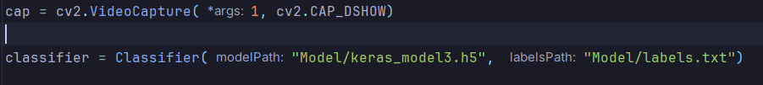

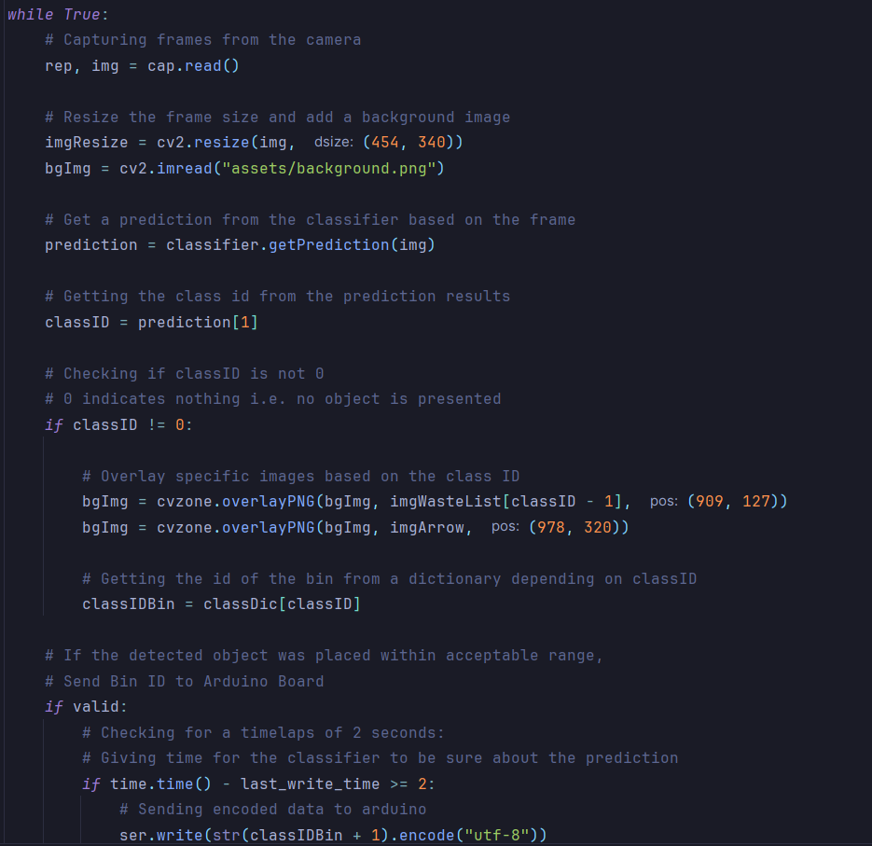

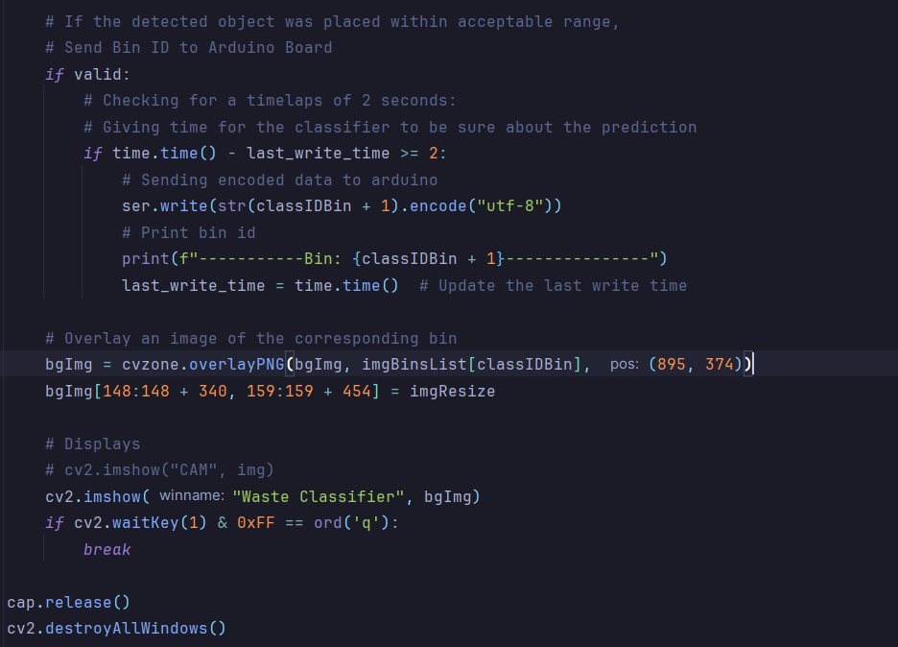

Figure 21 - Waste Classifier Code

The waste classification algorithm constantly records frames from the camera, process them in real time with the help of the AI waste classifier model “keras_model3.h5” and show the processed images in a window using OpenCV. The classifier returns a prediction which suggest what is the class id of the object which presents the material type (Plastic, Paper to name a few). According to this class id, the correct bin gets be obtained from a bin id dictionary and upon detecting an object, the bin id is encoded and send to the Arduino which will action the robotic arm to fetch the object and deposit in that particular bin. A graphical user interface will be displayed, showing the frame captured by the camera and shows the category of the object found in the frame together with its corresponding bin. Example images can be found below:

**Metal**

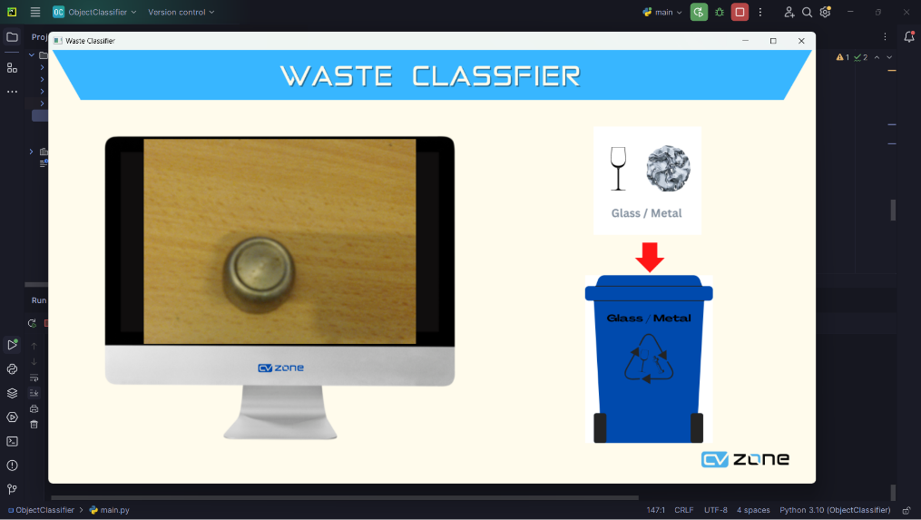

Figure 22 - Metal Detection

**Plastic**

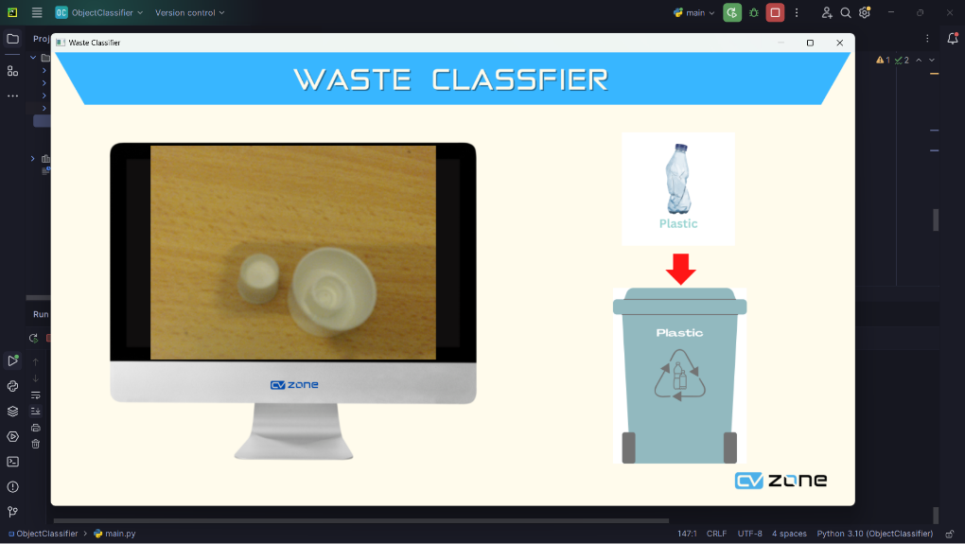

Figure 23 - Plastic Detection

**Paper**

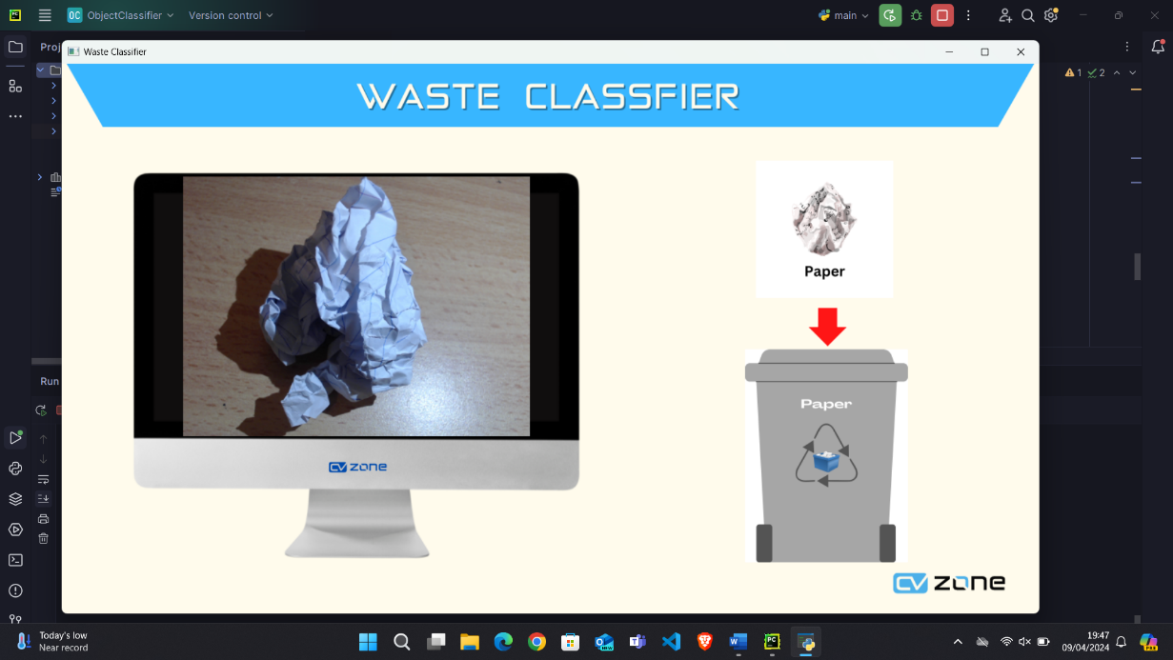

Figure 24 - Paper Detection

**Arduino Code**

Object Distance Verification

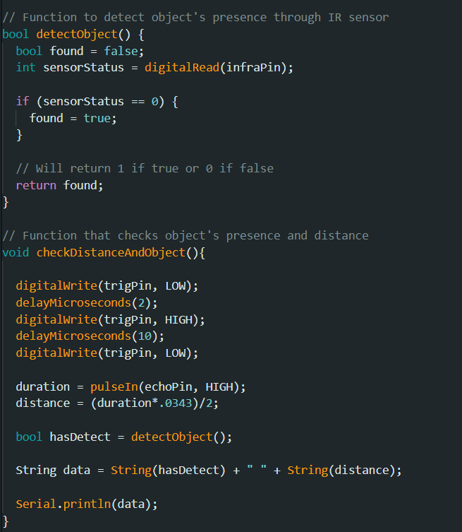

Figure 25 - Arduino Object Detection Code

The object and distance verification system involves 2 functions. The first function (detectObject()) reads digital input from the IR sensor module and returns a Boolean value(1 or 0) which indicates whether an object has been detected or not. The second one uses the HR-SC04 ultrasonic sensor to measure the distance to the object. It calls the first function to check the presence of an object and combines the value obtained from both sensors into a string, which is then passed to the python script via serial port.

Robotic Arm Mechanism

The robotic arm mechanism involves the use of various functions for the proper operation of the arm when handling an item.

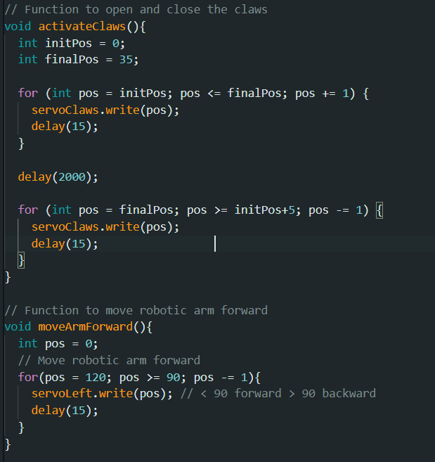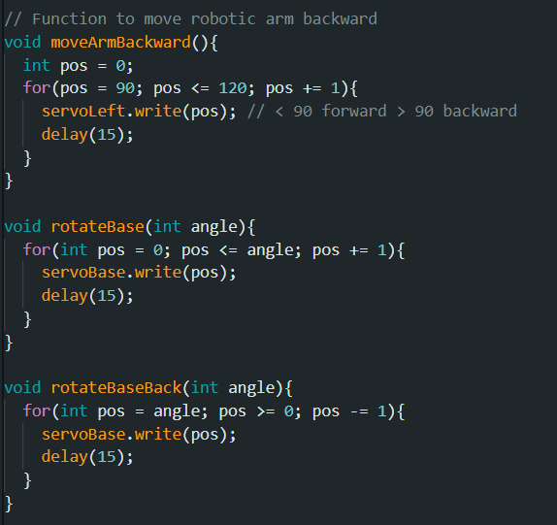

Figure 26 – Robotic Arm Mechanism Code 1

Each component of the robotic arm will have its own dedicated function where within each their respective servo motors will rotate back and forth between an initial and a final position which is indicated by the angle which the servo motors rotate. Each function introduces a delay of 15 milliseconds, controlling the movement speed of each component.

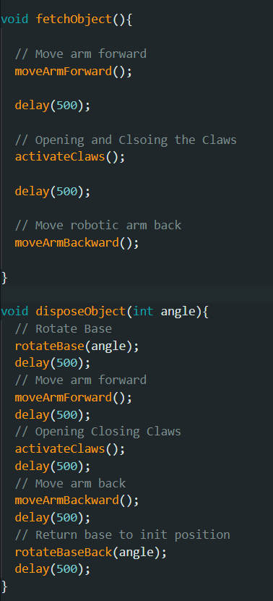

Figure 27 - Robotic Arm Mechanism Code 2

Item handling system involves 2 functions. The fetching function will move the robotic arm forward towards the object. The claws will open waiting for the user to put the object between the claws and close them. Then the robotic arm returns to its initial position.

The object disposal function will rotate the base through a define angle towards the corresponding bin. Upon reaching the bin, the following steps will be performed sequentially: the arm will move forward towards the bin, the claws will open and momentarily close drop the item, the arm will retract, and the base will return to its initial position. Hence completing the manoeuvre.

Robotic Arm Activation

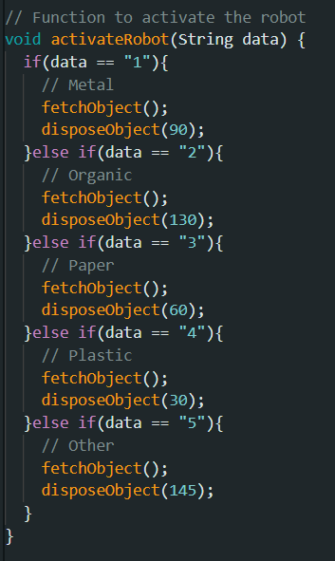

Figure 28 - Robot Activation Code

This function will handle the activation of the robot depending on the data send by the python script through serial port. The function checks the value of the parameter data and will specific action based on its value. For values from 1 to 5, the function will call the fetchObject() function to fetch the object from the user. Then the diposeObject() will follow. Depending on the value of data, the base will rotate through the angle passed in as parameter. Each angle represents the different strategic placement of the different bins .

# Testing

*Component Testing*

|  |  |  |
| --- | --- | --- |
| **Component** | **Requirements** | **Actual Output** |
| Arduino Mega 2560 Rev 3 | * Process instruction uploaded via the Arduino IDE * Communicate with actuators (servo motors) * Communicate with sensors (ultrasonic and infrared) * Communicate with the object classifier script written in Python through serial port. | * Successful instruction uploads to Arduino board. * Successful communication between board and actuators * Successful communication between board and sensors * Successful communication through serial port between board and object classifier script. |
| SG 90 Micro Servo | * Communicate with Arduino board. * Smooth and stable rotation * Accurate rotation through given angle provided by Arduino board | * Successful communication between servo and Arduino board. * Smooth and stable rotation for all 4 servos. * All 4 servos accurately rotate through given angle |
| HR-SC04 Ultrasonic Sensor | * Communicate with Arduino board. * Read and display object distance from sensor. * Send data to object classifier script through serial port | * Successful communication between sensor and Arduino board * Successful reading and display of object distance in real-time. * Successful sending of data to object classifier script through serial port |
| IR Sensor Module | * Communicate with Arduino board. * Detect presence of objects within line of sight * Send data to object classifier script through serial port | * Successful communication between sensor and Arduino board * Successful detection of objects within line of sight * Successful sending of data to object classifier script through serial port |
| Logitech Webcam | * Connection established with the computer. * Provide live footage for object classifier script written in Python using OpenCV for classifying items based on their material(Plastic, Paper, Metal etc..) * Communicate with Arduino board when sensors detect an object | * Successful connection with computer * Successful provision of live footage for object classifier * Successful communication with Arduino board when sensors detect an object |

Table 3 - Component Testing Table

*Functional Testing*

|  |  |  |
| --- | --- | --- |
| **Function** | **Requirements** | **Actual Output** |
| Communication between Arduino board and object classifier script | * Communication between both parties establish through serial port. * Arduino board to send and receive data from object classifier script. * Object classifier script to send and receive data from Arduino board. | * Successful communication between both parties * Successful communication from and to object classifier script * Successful communication from and to Arduino board |
| Live camera footage | * Object classifier script can detect and use webcam live footage. * Using OpenCV for object classifier | * Successful webcam detection and usage * Successful classification of objects into the 3 main categories (Paper, Plastic and Metal) |
| Detect item presence (Python Script) | * Establish connection with Arduino board. * Receive data from sensors. * Process information and send result to object classifier script * Activate voice feedback for invalid data | * Successful connection establishes with Arduino board. * Successful receipt of data from sensors * Successful data processing and sending result to object classifier script * Successful activation of voice feedback for invalid data |
| Move Robotic Arm  (C++ Arduino code) | * Establish connection between object classifier script * Receive data from script. * Activate robotic arm and start item handling based on data received. * Communicate feedback to object classifier script | * Successful connection established between the parties * Successful receipt of data from script * Successful robotic arm activation and item handling * Successful feedback communication to script |
| Waste Classification (Python Script) | * Detection of an item placed within acceptable range prior to classification. * Correct prediction about the object class(plastic, metal etc..) and its corresponding bin | * Successful detection of item within acceptable range. * Certain predication are not always accurate but for certain class there is a 100% prediction rate. |

Table 4 - Functional Testing Table

*System Testing*

|  |  |  |
| --- | --- | --- |
| System | Requirements | Result |
| Waste classification and handling (Whole system function) | * Detection of an item placed within acceptable range. * Correct classification of item material * Robotic arm activation and item handling * Item disposal in respective bin * Robotic arm returning to idle state | Test pass but the sorting accuracy is moderately high as the waste classifier can have difficulties in classifying item due to the following factors:   * Poor lighted room * Wrong camera orientation * Camera being out of focus. * Obstruction in the field of view when presenting the item |
| Robotic arm manoeuvre upon item classification | * Robotic arm extends forward. * The claws open and fetch the item. * Robotic arm base rotates towards the corresponding bin. * Claws open and dispose the item. * Robotic arm returns to idle state | Test pass but sometimes the base rotation isn’t very smooth, and the arm won’t extends forward on certain occasion. |
| Item handling upon item classification | * Claws open to fetch item from user. * Claws open to dispose the item in correct bin. | Test pass but bigger and wider objects cannot be handled by the claws. |
| Item distance and presence verification prior to item classification | * Detecting presence of an item * Verifying that the item is within the correct range. * Alert the user is object is not within the range | Test pass but delays ranging from 2 to 5 seconds are registered |

Table 5 - System Testing Table

# Evaluation and Conclusion

Sort X, the recycling robotic system which can autonomously sort waste based on their categories was successfully build and develop to meet the end goal of bringing a low-cost and eco-friendly robot that can promote recycling. The project comprising a robotic arm mimicking the movement of a human arm, an object detector built around an infrared and ultrasonic sensor for detecting objects in their surroundings and computer vision algorithms using opencv, an AI waste sorting model and a camera was able to fulfil the task previously mentioned.

The object detection , serving as a control tower, is responsible for the main robotic system operation which is to detect, classify the item and activate the robotic arm. Equipped with an infrared sensor module and ultrasonic sensor, the detector can efficiently identify the presence and measures the distance separating the waste item and the detector. As a result, the detect can then allow the robotic arm to operate the fetching and dropping operation. The camera and OpenCV work in tandem to classify the item according to its correct category with the assistance of an AI model trained with a large dataset of frequent waste items.

Autonomous waste sorting is Sort X main goal, and with the integration of all these components, the purpose of the robot can be fulfilled. The waste item is successfully picked up by the robot, who then , with the help of the computer vision algorithms that determined the object class, rotate towards the corresponding bin, and drop the item hence completing the sorting process of the item.

Yet, this project lacks in a lot of domains one of which is AI sorting model, which is moderately high and its highest accuracy during a simulation test was of between 50 to 60%. Enhancing the AI model by addition more waste items images in various settings to the training dataset can bolster the model in detecting irregular and uncommon objects. Furthermore, by incorporating strategies like continuous training and practice, the AI model can eventually be able to adjust to new waste kinds that are not always encountered in our daily lives. Also, with more advanced object detection algorithms such as deep learning algorithms, the robot’s ability to distinguish between different waste materials type can be further enhanced especially with objects that falls under the “other”, “plastic” and “paper” category which currently cause a lot of detection issues.

The robotic arm’s mechanism could be improved to maximize efficiency in item handling and boost the recycling robot’s overall performance. Further research should be done on finding solutions on refining the robotic arm’s mechanism to achieve better flexibility and seamless movement of the arm from point A to B. By improving the robotic arm’s design and construction, a great reduction in mechanical resistance and friction can be obtained, resulting in an increase in accuracy and fluidity in the movements when manipulating items. Additionally, incorporating a more sophisticated grippling system will improve its ability of handling items of varying size and shape allowing the robotic arm to handle a larger variety of objects which currently Sort X is not able to do.

In conclusion, this project implementation is a first step towards the development of any more complex, autonomous, and intelligent recycling robot. Through more research and development about robotics, computer vision and artificial intelligence, this robot hold promise for transforming the way waste management is being done.

# Reference List

1. Arduino Official Store. (n.d.). *Arduino Mega 2560 Rev3*. [online] Available at: <https://store.arduino.cc/products/arduino-mega-2560-rev3#:~:text=or%203.3V>.
2. Axios. (2023) Recycling robots powered by AI could help divert more trash from landfills. Retrieved from <https://www.axios.com/2023/04/04/recycling-robots-ai-landfill>
3. Conner-Simons, A. (2019). *These robots can sort recycling*. [online] World Economic Forum. Available at: <https://www.weforum.org/agenda/2019/04/robots-that-can-sort-recycling/>.
4. Despatch. (2019). *MIT’s Recycling Robot ‘Rocycle’ Can Detect Paper, Plastic, and Metal By Touch*. [online] Available at: <https://www.despatch.com/blog/recycling-robot-rocycle-can-detect-paper-plastic-and-metal-by-touch/#:~:text=RoCycle%20was%20found%20to%20be>.
5. evs (2023). *Servo Motor for Robotic Arm: What Will Happen？ - EVS Robot*. [online] EVS Robot. Available at: <https://www.evsint.com/servo-motor-for-robotic-arm-what-will-happen%EF%BC%9F>.
6. Fahrion, D. (2024). *Waste Management Technologies: Upcoming Innovations To Make Waste Management Less Of A Challenge*. [online] Waste Control Incorporated. Available at: <https://wastecontrolinc.com/2024/02/19/waste-management-technologies/#:~:text=Robots%20like%20Max%2DAI%2C%20developed>.
7. FasterCapital. (n.d.). *Ecosystem Disruption*. [online] Available at: <https://fastercapital.com/keyword/ecosystem-disruption.html#:~:text=The%20delicate%20balance%20of%20Earth>.
8. Google (n.d.). *Teachable Machine*. [online] teachablemachine.withgoogle.com. Available at: <https://teachablemachine.withgoogle.com/>.
9. HowToRobot. (2023). *Recycling Robots: How They Work & Are They Worth the Investment?* [online] Available at: <https://howtorobot.com/expert-insight/recycling-robots#:~:text=Artificial%20Intelligence%20and%20computer%20vision>.
10. IBM (2019). *Computer Vision*. [online] IBM. Available at: <https://www.ibm.com/topics/computer-vision>.
11. luciaclemares (2023). *Uses and applications of Artificial Intelligence in robotics*. [online] Telefónica. Available at: <https://www.telefonica.com/en/communication-room/blog/uses-and-applications-of-artificial-intelligence-in-robotics/>.
12. MIT News | Massachusetts Institute of Technology. (n.d.). *Robots that can sort recycling*. [online] Available at: <https://news.mit.edu/2019/mit-robots-can-sort-recycling-0416>.
13. MIT Technology Review. (n.d.). *This robot can sort recycling by giving it a squeeze*. [online] Available at: <https://www.technologyreview.com/2019/04/11/1141/this-robot-can-sort-recycling-by-giving-it-a-squeeze/>.
14. Mok, K. (2019). *MIT and Yale’s RoCycle Robot Can Sort Recyclables by ‘Feeling’ Them*. [online] The New Stack. Available at: <https://thenewstack.io/mit-and-yales-rocycle-robot-can-sort-recyclables-by-feeling-them/>.
15. UNEP (2017). *Solid waste management*. [online] UNEP - UN Environment Programme. Available at: <https://www.unep.org/explore-topics/resource-efficiency/what-we-do/cities/solid-waste-management#:~:text=Poor%20waste%20management%20%2D%20ranging%20from>.
16. UNEP. (2018). *Our planet is drowning in plastic pollution*. [online] Available at: <https://www.unep.org/news-and-stories/story/our-planet-drowning-plastic-pollution>.
17. United States Environmental Protection Agency (2022). *National Overview: Facts and Figures on Materials, Wastes and Recycling | US EPA*. [online] United States Environmental Protection Agency. Available at: <https://www.epa.gov/facts-and-figures-about-materials-waste-and-recycling/national-overview-facts-and-figures-materials>.
18. www.eea.europa.eu. (2023). *Editorial — Caring for the environment is caring for ourselves*. [online] Available at: <https://www.eea.europa.eu/en/newsroom/editorial/editorial-caring-for-the-environment#:~:text=Reducing%20and%20preventing%20pollution%20improves>.
19. www.javatpoint.com. (n.d.). *Arduino Mega - JavaTpoint*. [online] Available at: <https://www.javatpoint.com/arduino-mega#:~:text=The%20advantage%20of%20using%20the>.
20. www.linkedin.com. (n.d.). *Arduino vs. Raspberry Pi for Robotics: Navigating the Perfect Choice 🤖🔍*. [online] Available at: <https://www.linkedin.com/pulse/arduino-vs-raspberry-pi-robotics-navigating-perfect-choice-kikani/>.
21. www.linkedin.com. (n.d.). *Exploring OpenCV-Python: Features, Benefits, and Usage*. [online] Available at: <https://www.linkedin.com/pulse/exploring-opencv-python-features-benefits-usage-aditya-mishra-ljvjc/> .
22. YoungWonks (n.d.). *What is OpenCV, what does it do and where is it used?* [online] YoungWonks. Available at: <https://www.youngwonks.com/blog/What-is-OpenCV#:~:text=OpenCV%20stands%20for%20Open%20Source>.

‌

‌

‌